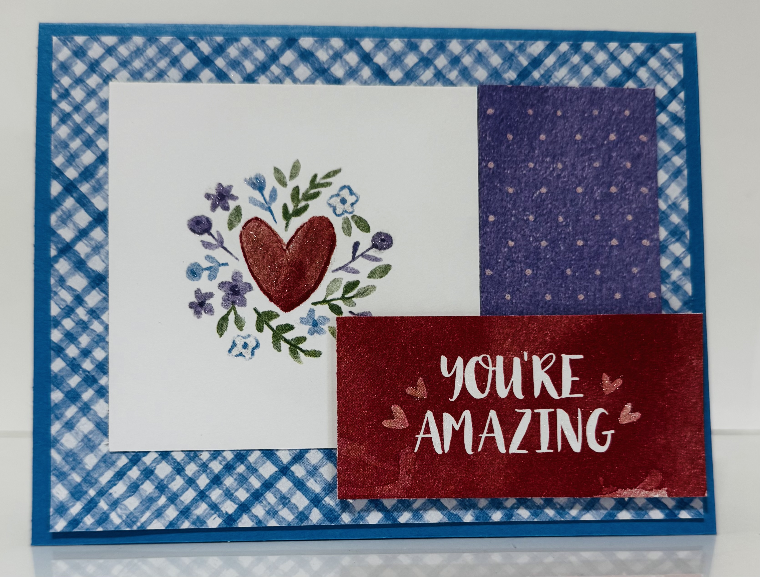
Love Notes: You’re Amazing
Stampin’ Up! Images © 1990-2025 Stampin’ Up!®
Supplies:
- DSP: Love Notes (166985)
- Card Stock- Azure Afternoon [161719], Basic White [166780],
- Misc: Clear Wink Of Stella Glitter Brush [141897]

Measurements:
- Azure Afternoon: 5 1/2 x 8 1/2, scored at 4 1/4
- Basic White: 4 x 5 1/4 (inside card)
- DSP: 4 x 5 1/4, 3 x 3, 1 1/2 x 3, plus sentiment
Instructions:
- Adhere largest piece of DSP to the card base. attach strip of DSP to card.
- Attach sentiment to DSP with dimensionals. Adhere this piece to card base.
- Add Wink of Stella to Heart and flowers.

