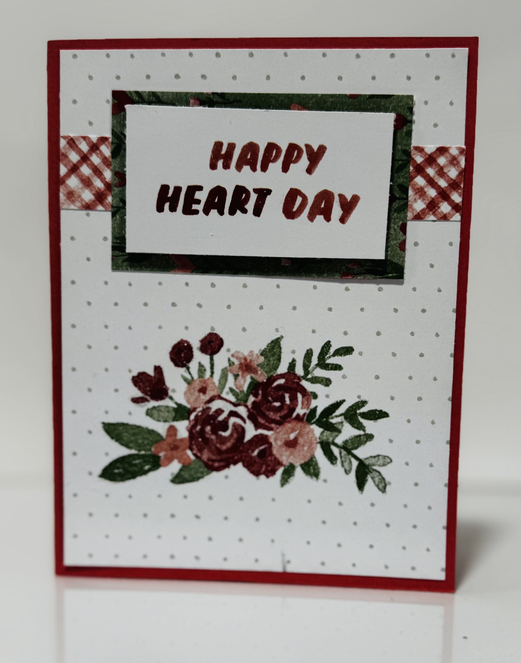
Love Notes: Happy Heart Day
Stampin’ Up! Images © 1990-2025 Stampin’ Up!®
Supplies:
- DSP: Love Notes (166985)
- Card Stock- Flirty Flamingo [141416], Basic White [166780],
- Misc: Clear Wink Of Stella Glitter Brush [141897]

Measurements:
- Flirty Flamingo: 5 1/2 x 8 1/2, scored at 4 1/4
- Basic White: 4 x 5 1/4 (inside card)
- DSP: 4 x 5 1/4, 3/4 x 4, 2 1/2 x 1 3/8(sentiment), 3 X 1 3/4
Instructions:
- Adhere largest piece of DSP to the card base. attach strip of DSP to card.
- Attach sentiment to DSP with dimensionals. Adhere this piece to card base.
- Add Wink of Stella to flowers. I also added it to the words.

