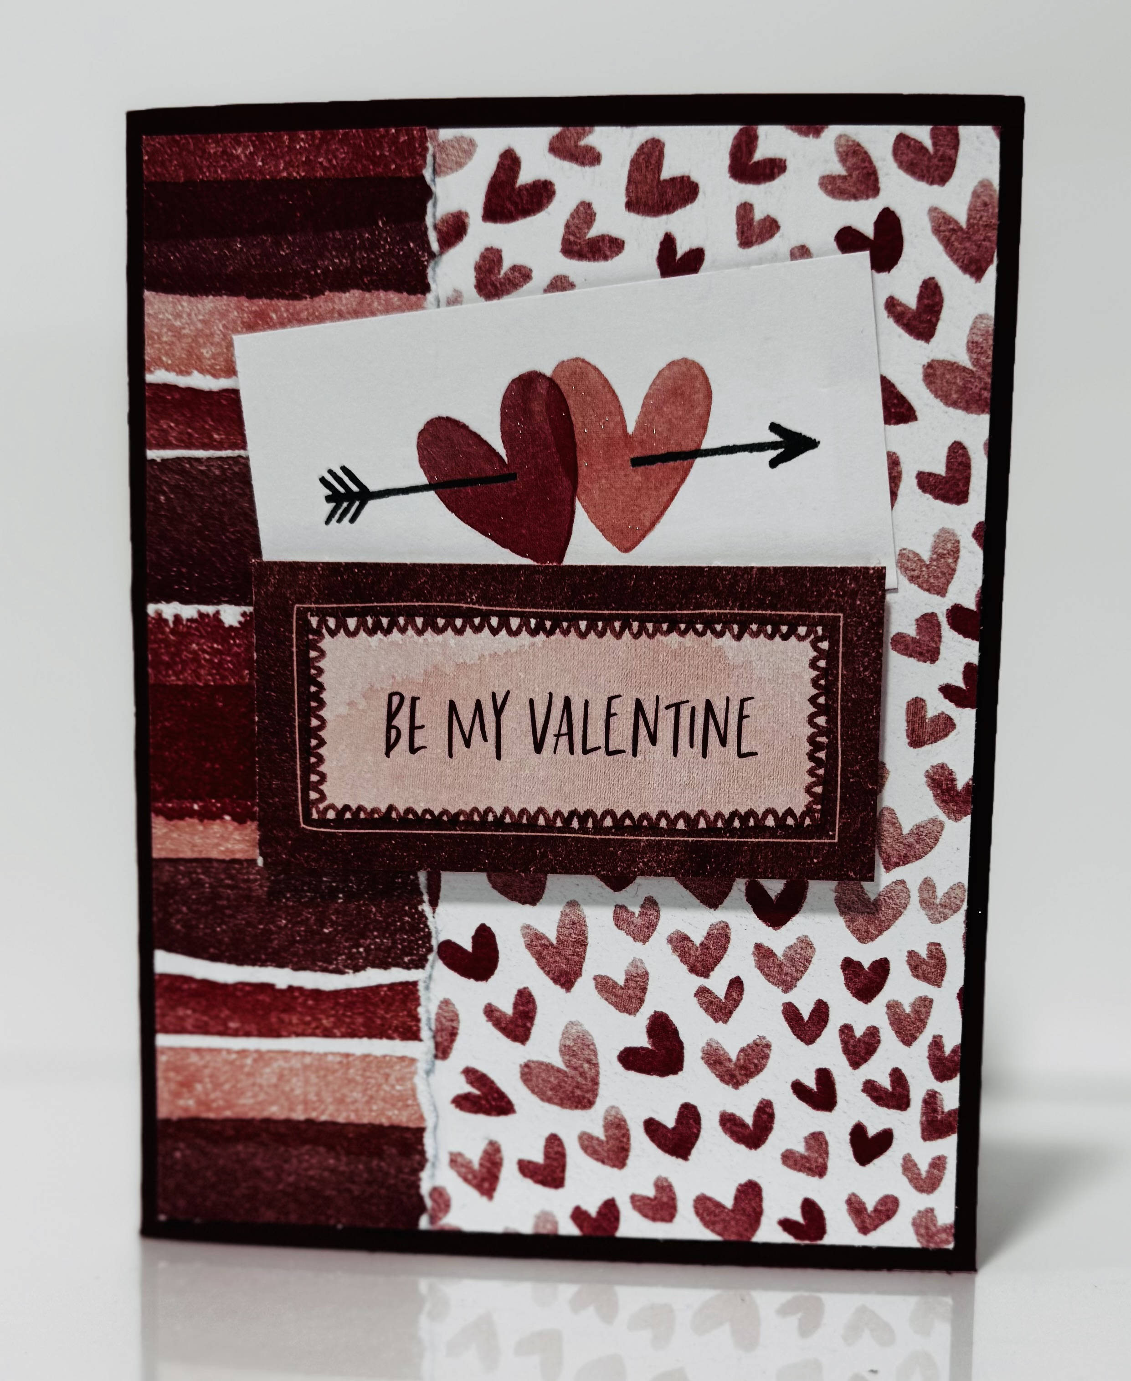
Love Notes: Be My Valentine
Stampin’ Up! Images © 1990-2025 Stampin’ Up!®
Supplies:
- DSP: Love Notes (166985)
- Card Stock- Cherry Cobbler Cardstock [119685], Basic White [166780],
- Misc: Clear Wink Of Stella Glitter Brush [141897]

Measurements:
- Cherry Cobbler: 5 1/2 x 8 1/2, scored at 4 1/4
- Basic White: 3 1/4 x3 1/4, 4 x 5 1/4 (inside card)
- DSP: 3 X 5 1/4 and 1 1/4 x 5 1/4
Instructions:
- Tear smaller strip of DSP along the edge. Attach 3 x 5 1/4 piece to card base. Attach torn piece over the edge of the other piece.
- Cut out the sentiment and the hearts from DSP.
- Attach heart piece to card base.
- Attach sentiment piece to card base with dimensionals.
- Add Wink of Stella to hearts.

